
Name: BOUTEGHRINE Belqassim
Student ID: 201224010108

Why the frequency spectrum is meaningful, engineering applications of signal spectrum

Introduction:
It is very common for information to be encoded in the sinusoids that form a signal. This is true of naturally occurring signals, as well as those that have been created by humans. Many things oscillate in our universe. For example, speech is a result of vibration of the human vocal cords; stars and planets change their brightness as they rotate on their axes and revolve around each other; ship's propellers generate periodic displacement of the water, and so on. The shape of the time domain waveform is not important in these signals; the key information is in the frequency, phase and amplitude of the component sinusoids. The FT, DTFT, DFT are used to extract these information.
Illustration of the signal spectrum:
It was shown over one hundred years ago by Baron Jean Baptiste Fourier that any waveform that exists in the real world can be generated by adding up sine waves. We have illustrated this in Figure -01- for a simple waveform composed of two sine waves. By picking the amplitudes, frequencies and phases of these sine waves correctly, we can generate a waveform identical to our desired signal. Conversely, we can break down our
real world signal into these same sine waves. It can be shown that this combination
of sine waves is unique; any real world signal can be represented by only one combination of sine waves. Figure -02-(a) is a three dimensional graph of this addition of sine waves. Two of the axes are time and amplitude, familiar from the time domain. The third axis is frequency which allows us to visually separate the sine waves which add to give us our complex waveform. If we view this three-dimensional graph along the frequency axis we get the view in Figure -02-(b). This is the time domain view of the sine waves. Adding them together at each instant of time gives the original waveform.
However, if we view our graph along the time axis as in Figure -02-(c), we get a totally different picture. Here we have axes of amplitude versus frequency, what is commonly called the frequency domain. Every sine wave we separated from the input appears as a vertical line. Its height represents its amplitude and its position represents its frequency. Since we know that each line represents a sine wave, we have uniquely characterized our input signal in the frequency domain. This frequency domain representation of our signal is called the spectrum of the signal. Each sine wave line of the spectrum is called a component of the total signal.
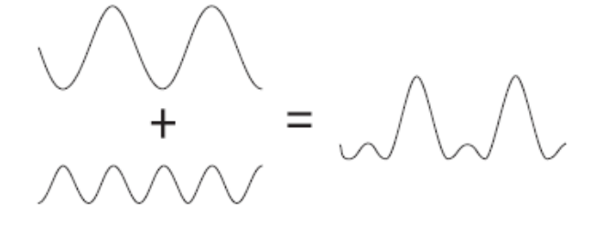

Figure -01-
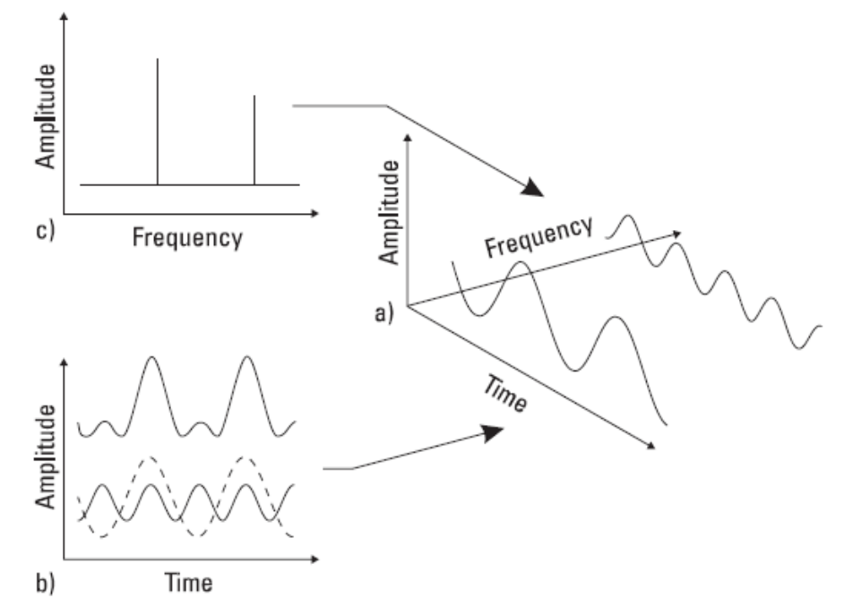

Figure -02-

Let us now look at a few common signals in both the time and frequency domains. In Figure -03-(a), we see that the spectrum of a sine wave is just a single line. We expect this from the way we constructed the frequency domain. The square wave in Figure -03-(b) is made up of an infinite number of sine waves, all harmonically related. The lowest frequency present is the reciprocal of the square wave period. These two examples illustrate a property of the frequency transform: a signal which is periodic and exists for all time has a discrete frequency spectrum. This is in contrast to the transient signal in Figure -03-(c) which has a continuous spectrum. This means that the sine waves that make up this signal are spaced infinitesimally close together.
Another signal of interest is the impulse shown in Figure -03-(d). The frequency spectrum of an impulse is flat, i.e., there is energy at all frequencies.
It would, therefore, require infinite energy to generate a true impulse. Nevertheless, it is possible to generate an approximation to an impulse which has a fairly flat spectrum over the desired frequency range of interest.
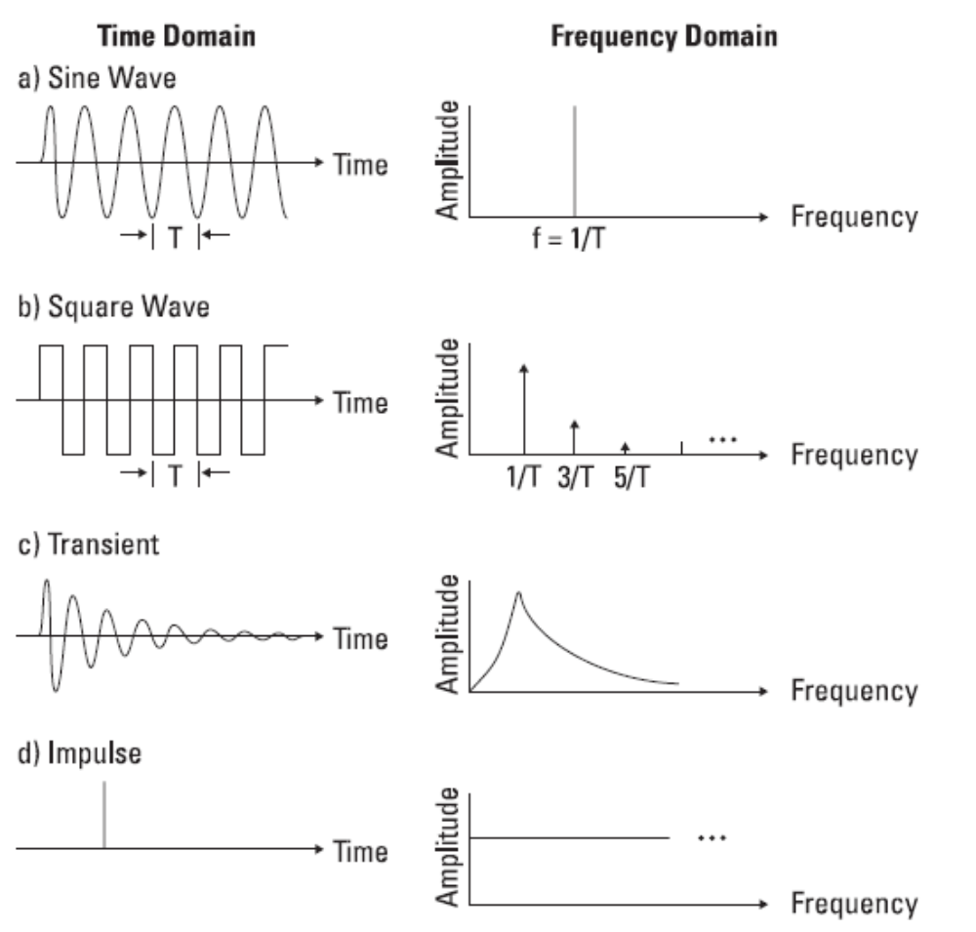

Figure -03-

The Frequency Domain: A Natural Domain
At first the frequency domain may seem strange and unfamiliar, yet it is an important part of everyday life. Your ear-brain combination is an excellent frequency domain analyzer. The ear-brain splits the audio spectrum into many narrow bands and determines the power present in each band. It can easily pick small sounds out of loud background noise thanks in part to its frequency domain capability. A doctor listens to your heart and breathing for any unusual sounds. He is listening for frequencies which will tell him something is wrong. An experienced mechanic can do the same thing with a machine. Using a screwdriver as a stethoscope, he can hear when a bearing is failing because of the frequencies it produces. So we see that the frequency domain is not at all uncommon. We are just not used to seeing it in graphical form. But this graphical presentation is really not any stranger than saying that the temperature changed with time like the displacement of a line on a graph.

Engineering applications of signal spectrum:
- Electrical and mechanical engineering applications:

Suppose we wish to measure the level of distortion in an audio oscillator. Or we might be trying to detect the first sounds of a bearing failing on a noisy machine. In each case, we are trying to detect a small sine wave in the presence of large signals. Figure -04- shows a time domain waveform which seems to be a single sine wave. But Figure -05- shows in the frequency domain that the same signal is composed of a large sine wave and significant other sine wave components (distortion components). When these components are separated in the frequency domain, the small components are easy to see because they are not masked by larger ones. The frequency domain’s usefulness is not restricted to electronics or mechanics. All fields of science and engineering have measurements like these where large signals mask others in the time domain. The frequency domain provides a useful tool in analyzing these small but important effects.

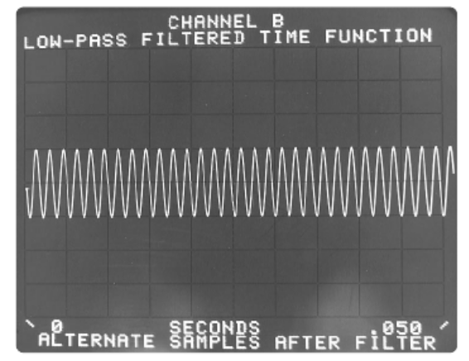
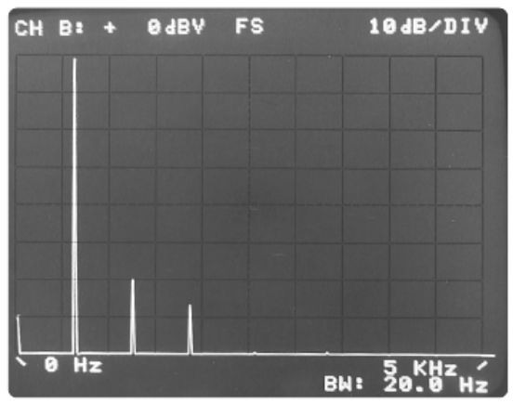

Figure -04- Figure -05-

2. Computer engineering application (Steganography):
Steganography is the art and science of hiding information in images. The basic idea is not to let the enemy know that message is being transmitted. This is different from
message encryption, which is designed to make it hard to understand the message once a
message is found. Steganography makes it hard to find the message itself. For instance, in
Figure1, one of the images has the preamble of the US constitution embedded in it. Can you guess? Looking at the images it is impossible to figure it out. There are various ways for performing steganography and there are various ways to figure out if there is a hidden
message in an image. Detecting steganography is another problem, which we will leave for another day. In this problem, we are going to look at one method for doing steganography using the Discrete Fourier Transform, computed using the Fast Fourier Transform.
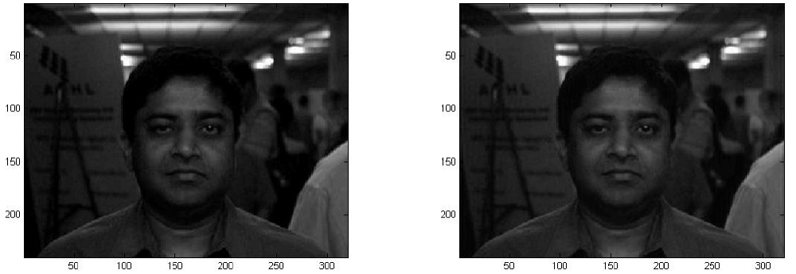

Figure -06-

Figure -06- Which of these two images has a hidden message embedded in it? One of them has the amendments of the US constitution in it.

Formulation:
Image is a collection of gray level values at set of predetermined sites known as pixels, arranged in an array. These gray level values are also known as image intensities. For this problem, an image is nothing but a two dimensional array of numbers, I (m, n). The size of the array is the size of the image. One place to hide information in images is in the Fourier or frequency domain of images. Yes, we can define “frequency” of images too. Frequency in this context is defined with respect to the inverse of pixel or spatial units and not as inverse of time units. Imagine stripped patterns, such as that one would see on shirts or on zebra. High frequency patterns would be closely spaced strips and low-frequency patterns would be those strips are that are widely spaced. Also, since images are two-dimensional quantities, the Fourier transform of an image is also two dimensional. Since images are defined at discrete points, we will consider the discretized version of the Fourier transform. The discrete Fourier transform of an image (DFT) is given by:

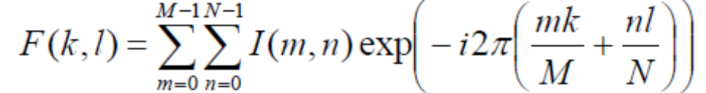

Note the DFT is also a 2D array of the same size as the image, i.e. M by N. The inverse
DFT (IDFT) is given by:

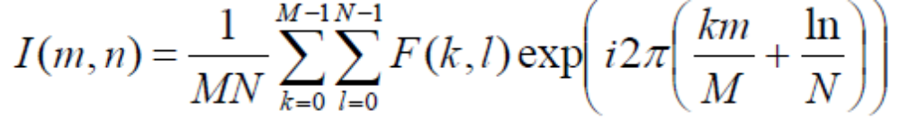

Figure -7- shows an example of the DFT, with just the magnitude visualized as images. There is, of course, the phase component too, which is not shown here. Note that the visualization might appear to be rather unconventional to you. Brighter regions correspond to larger magnitudes. As we see most of the information is towards the low-frequencies. So, it is not a good idea to change those. Higher frequencies control the sharpness of the image, so we cannot really mess around with that too. It is in the mid-range that we will store our information.
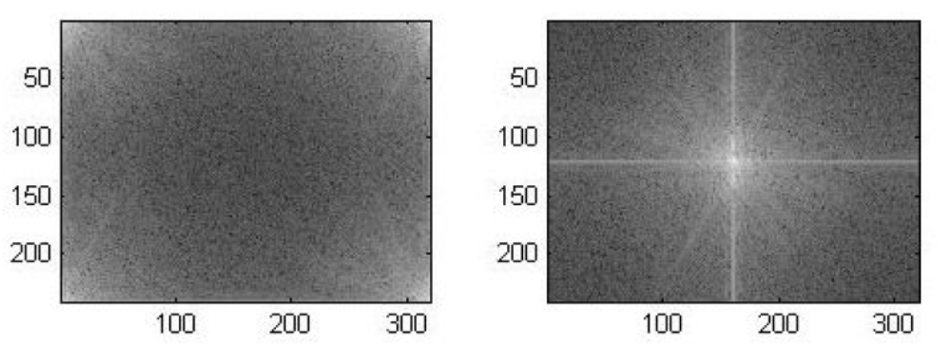

Figure -7- Discrete Fourier Transform of the face image show in Figure -6-.

We show just the magnitude of the transform visualized as intensity. Whiter appearance corresponds to larger values. One the left is the unshifted version with the low frequencies at the corners and on the right is the shifted version with the zero frequency at the center. We will store our information by changing the magnitude of the DFT in an annular region, centered on the zero frequency information. We will simple replace the magnitude of the DFT in this region with corresponding ASCII value of the characters in the message. We will leave the phase information unchanged. Figure -8- shows examples of this hiding using the text of the amendment of the US constitution.

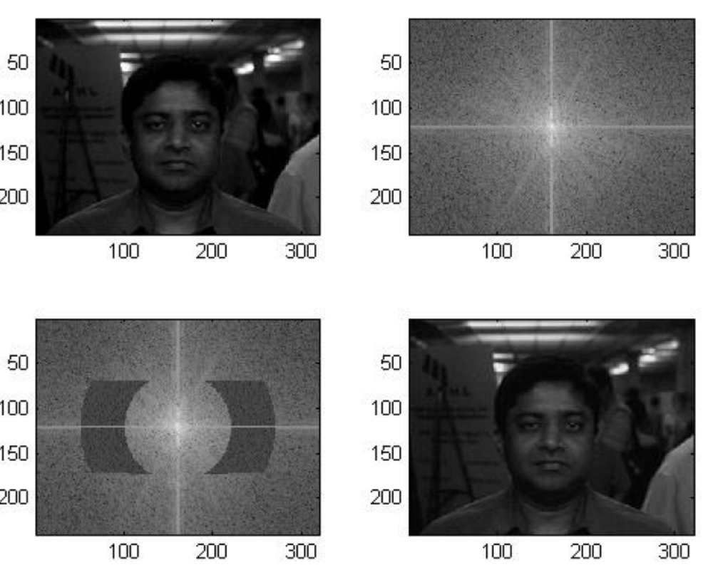

Figure -08-

Figure -8- Top row shows the original image along with (shifted, centered) magnitude of the DFT. In the bottom row, we have the DFT magnitude image, with the message embed in it. The portion where the message is stored is obviously the darker annular pieces. The image on the right of the bottom row is the reconstructed image. Note from the reconstructed image, it is hard to make out if any message has been stored in it. To retrieve the message, we simply have to perform the DFT (or rather FFT) of the received images, and just read of the magnitude in the annular region, whose location has been decided upon at an earlier stage, through different channels. The retrieve step is also fairly simple.

Conclusion:
Any signal that can be represented as amplitude that varies with time has a corresponding frequency spectrum. This includes familiar concepts such as visible light (color), musical notes, radio/TV channels, and even the regular rotation of the earth. When these physical phenomena are represented in the form of a frequency spectrum, certain physical descriptions of their internal processes become much simpler. Often, the frequency spectrum clearly shows harmonics, visible as distinct spikes or lines at particular frequencies that provide insight into the mechanisms that generate the entire signal. This report shows the great importance of the frequency spectrum, and how it is so meaningful in signal processing. The engineering examples shown in this report are just some applications of the vast frequency spectrum area.

